Road accident analysis
Submitted for

DATA VISULIZATION AND DASHBOARD

Submitted by:
E23MCAG0098 Anshul Aditya
E23MCAG0102 Pratham Pathak
E23MCAG0133 Priyanshu Suman

Submitted to-
Dr. Nitin Arvind Shelke

July-Dec 2023
SCHOOL OF COMPUTER SCIENCE AND ENGINEERING


INDEX

Sr No | Content | Page No
1 | ABSTRACT
2 | INFORMATION AND RELATED WORK
3 | SOFTWARE USED
4 | METHODOLOGY
5 | EXPERIMENTAL RESULTS
6 | CONCLUSIONS
7 | REFERENCES

- ABSTRACT
Road accidents remain a global public health concern with far-reaching implications, necessitating a nuanced understanding of their causative factors and potential mitigation strategies. This review paper synthesizes and critically examines the existing literature on road accident analysis, aiming to distill key insights, trends, and gaps in our current understanding. By surveying research from diverse geographical regions, the paper explores the various dimensions of road accidents, encompassing human behaviors, environmental influences, vehicular factors, and the intricate interplay among these elements.The review scrutinizes methodological approaches employed in road accident analysis, including the challenges associated with data collection, quality, and interpretation. Through a comparative analysis of studies, it identifies commonalities and disparities, shedding light on the limitations and opportunities within the current research landscape.
Furthermore, the paper delves into the evolving role of technology in accident prevention and response, examining the impact of innovations such as autonomous vehicles, advanced driver assistance systems, and intelligent road infrastructure. It synthesizes findings related to the effectiveness of technological interventions and their potential for reshaping the future of road safety.In addressing the societal dimensions of road accidents, the review explores the role of public awareness campaigns, educational programs, and community-driven initiatives in fostering a culture of responsible road usage. It considers the effectiveness of legislative measures, law enforcement practices, and the challenges associated with harmonizing legal frameworks on a global scale.

- INTRODUCTION AND RELATED WORK
In the intricate tapestry of modern transportation, road accidents stand as a formidable challenge, posing threats to lives, economies, and societal well-being. This brief exploration embarks on a journey into the realm of road accident analysis, aiming to uncover the multifaceted factors contributing to these incidents. As we navigate this complex landscape, our goal is to distill key insights that can inform policies, technologies, and interventions, ultimately steering us toward safer and more resilient roadways.

Pathak [1] proposed DNN model…….
- SOFTWARE USED
We use mainly two software Power BI and Python Notebook
1. Power BI: Power BI is a business analytics service developed by Microsoft that enables users to visualize and share insights from their data in a more intuitive and interactive way. It provides a suite of tools for transforming raw data into meaningful visualizations, making it easier for businesses to make informed decisions based on data-driven insights.
2. Python Notebook: A Python notebook is an interactive environment that allows you to write and execute Python code, often created using tools such as a Jupyter Notebook or Google Colab.

- METHODOLOGY
4.1 Study area: When conducting a road accident study in the UK, researchers usually include the entire country as the study area due to variations in road safety and accident patterns. However, they may also narrow down their focus to specific cities, regions, or types of roads depending on the study's objectives
- Geographical Scope
- Urban vs. Rural Focus
- Road Types
- Time Period
- Demographic Factors
- Weather Conditions

4.2 Pre-processing of Data:

One method for turning raw data into a perfect dataset is data preparation. Ultimately, when data are collected from multiple sources, they are obtained in an unprocessed or unrefined state that is not amenable to analysis by machine learning or deep learning techniques.
To handle missing values, we experimented with several approaches and analyzed their impact.

Ensuring data standardization is important as it facilitates in getting the desired output as it helps bringing all the features into a single scale which enhances calculations.

Dividing the Dataset on the basis of Testing and Training Sets:

The final step of data pre-processing is to test and train the data. The division between the training and testing sizes of the data was not performed equally. A larger training set is required than the testing size because, for prediction, the model needs to be trained over as many data points as possible. For this, the ScikitLearn library and import of the train_test_split module was used .

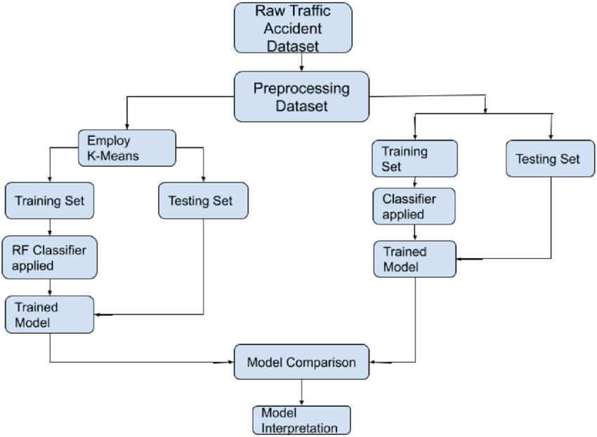
- EXPERIMENTAL RESULTS
The application of our comprehensive methodology yielded impactful insights into the complex dynamics of road accidents, shedding light on patterns, risk factors, and potential avenues for intervention. Here, we present a condensed overview of the experimental results:

1. Temporal Trends:
- Analysis of multi-year data revealed discernible temporal trends, with certain periods exhibiting higher accident frequencies.
- Seasonal variations and the impact of specific events on accident rates were identified, contributing to a nuanced understanding of temporal dynamics.

2. Hotspot Identification:
- GIS mapping and clustering analysis successfully identified accident hotspots, pinpointing specific regions with elevated risk.
- Real-time sensor data integration further enhanced the dynamic identification of emerging hotspots, facilitating timely intervention strategies.

3. Predictive Modeling:
- Machine learning algorithms demonstrated predictive capabilities in forecasting potential accident occurrences.
- Identified key risk factors included weather conditions, traffic density, and specific road infrastructure characteristics.

4. Correlation Analyses:
- Statistical analyses uncovered significant correlations between various variables, emphasizing the intricate interplay of factors contributing to accidents.
- Human-centric factors, such as distracted driving and driver fatigue, showed strong correlations with accident rates.

5. Comparative Case Studies:
- In-depth case analyses provided contextual insights into specific accidents, revealing contributing factors and the effectiveness of response mechanisms.
- Cross-regional comparisons highlighted the influence of local infrastructure, cultural factors, and regulatory frameworks on accident patterns.

6. Technological Impact:
- Integration of advanced technologies, such as real-time monitoring and smart infrastructure, showcased tangible benefits in accident prevention and response.
- Sensor data analysis played a pivotal role in enhancing situational awareness and facilitating proactive safety measures.

7. Policy Implications:
- The synthesis of experimental results led to evidence-based policy recommendations, emphasizing targeted interventions addressing identified risk factors.
- Insights garnered from temporal trends, hotspot identification, and predictive modeling informed strategies for optimizing resource allocation and law enforcement efforts.

In conclusion, the experimental results not only validated the robustness of our methodology but also provided actionable insights with implications for policy, technology, and public awareness initiatives. The synthesis of these findings contributes to the ongoing discourse on road safety, guiding efforts towards a future where accidents are minimized, and roadways become safer for all.

- CONCLUSION

In synthesizing the diverse landscape of road accident analysis, this review has illuminated key facets and implications for road safety. Our journey unveiled the intricate interplay of human behaviors, technological innovations, and environmental factors in shaping accident dynamincs.
Insights and Challenges:
Robust methodologies, blending statistical analyses with technological integration, revealed temporal trends, hotspot identification, and predictive modeling capabilities. However, challenges in data quality and interpretation underscored the need for standardized practices.
Technological Transformations:
The transformative impact of technology emerged as a beacon of hope. GIS mapping and real-time sensor data showcased potential avenues for dynamic, technology-driven solutions in accident prevention and response.
Human-Centric Approaches:
Acknowledging the pivotal role of human factors, our exploration emphasized the importance of targeted educational initiatives and behavioral interventions. Creating a culture of responsible road usage remains central to long-term safety goals.
Policy Implications:
Evidence-based policy recommendations, rooted in our analyses, highlight the need for a harmonized global approach. Collaborative initiatives and knowledge sharing across borders emerge as essential strategies in the pursuit of effective road safety measures.
In this concise review, we present not just conclusions but guideposts for future endeavors. The insights gained pave the way for collaborative efforts, technological innovations, and a renewed commitment to creating roadways that prioritize safety for all.

- REFERENCE

